ATTENTION: 18-19 YEAR OLDS

I am a retired New York City high school guidance counselor. With the help of students and adults, I have developed and facilitated a program known as the "Anger Management Power (A.M.P.) Program." I’m the author of the book entitled, Peace the Other Side of Anger (2011), based on this program for parents/guardians and professionals helping youngsters handle anger in positive ways.

I’m in the process of revising this book by adding additional chapters on the pandemic, gun violence, and social media -- all of which had not existed or have the impact they have today. Your opinions are valuable and your perceptions meaningful. Three surveys on these subjects have been created and need your input. Your names will NOT be used. The only identifying information will be your gender, age and grade.

Please access these surveys on the link and/or QR Code below. They should only take you a few minutes to complete.

Thank you for your participation.

https://forms.gle/aa4jCEXfdUxvNixm6
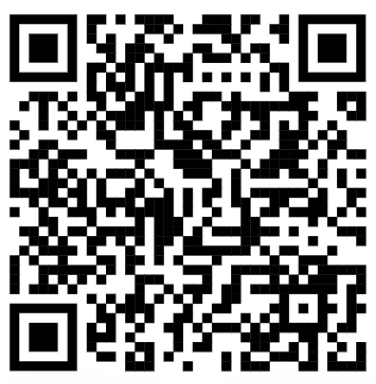

Dave Wolffe, MS, Author
peacefulyouth422@yahoo.com

